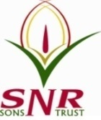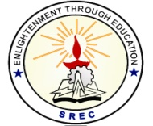**SRI RAMAKRISHNA ENGINEERING COLLEGE**

[Educational Service: SNR Sons Charitable Trust]

[Autonomous Institution, Reaccredited by NAAC with ‘A+’ Grade]

[Approved by AICTE and Permanently Affiliated to Anna University, Chennai]

[ISO 9001:2015 Certified and all eligible programmes Accredited by NBA]

VATTAMALAIPALAYAM, N.G.G.O. COLONY POST, COIMBATORE – 641 022.

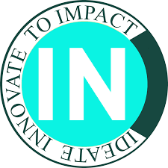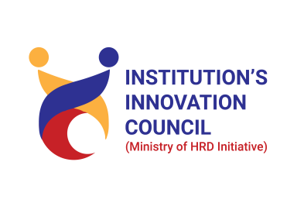

**SREC CoIN – MoE’s Institution Innovation Council 6.0**

|  |  |
| --- | --- |
| **S.No.** | **CONTENTS** |
|  | Permission Letter |
|  | Report |
|  | Photos (With Geotag) |
|  | Poster |
|  | Resource Person Profile |
|  | Attendance |
|  | Feedback |
|  | Certificate(if any) |
|  | Bill Settlement (Along with proof) |

**Note:** Also requested to upload the soft copy details in the given Google form link https://forms.gle/n7WtpAKgtxTmxYMN8

**SRI RAMAKRISHNA ENGINEERING COLLEGE**

[Educational Service: SNR Sons Charitable Trust]

[Autonomous Institution, Reaccredited by NAAC with ‘A+’ Grade]

[Approved by AICTE and Permanently Affiliated to Anna University, Chennai]

[ISO 9001:2015 Certified and all eligible programmes Accredited by NBA]

VATTAMALAIPALAYAM, N.G.G.O. COLONY POST, COIMBATORE – 641 022.





**SREC CoIN – MoE’s Institution Innovation Council 6.0**

***Report on Intellectual Property Rights Workshop***

**ACADEMIC YEAR:** 2023-2024

**ACTIVITY:** IIC Calender

**QUARTER:** Q3

**PROGRAM / ACTIVITY NAME: Workshop on Intellectual Property Rights**

**PROGRAM TYPE**:  **Workshop**

**PROGRAM THEME:** IPR & Technology Transfer

**DURATION OF THE ACTIVITY (In Hrs): 8** Hours

**START DATE: 16.04.2024**

**END DATE: 16.04.2024**

**NO. OF STUDENT PARTICIPANTS: 73**

**NO. OF FACULTY PARTICIPANTS: 73**

**NO. OF EXTERNAL PARTICIPANTS (If any): Nil**

**EXPENDITURE AMOUNT (If any):**2000/-

**VENUE:** CSE SEMINAR HALL

**MODE OF DELIVERY:** Offline

**OBJECTIVE: (Max 100words)**

The primary goal of an IPR workshop is often to educate participants about the importance of intellectual property rights, including patents, trademarks, copyrights, and trade secrets. Workshops may cover topics such as identifying infringement, pursuing legal action, and resolving disputes through litigation.

Workshops may explore how IP rights can incentive innovation and foster economic growth.aimed at startups may focus on IP strategies for small businesses, while those targeting academic researchers may cover topics such as patenting inventions or publishing rights.

**BENEFITS IN TERMS OF LEARNING / SKILL/ KNOWLEDGE OBTAINED:**

**(Max 150 words)**

* A workshop on Intellectual Property Rights was conducted by SREC CoIN, MoE-IIC in association with SREC IPR Cell on 16.04.2024.
* There were 70 participants from various department of SREC participated in the workshop to better compliance with IP laws and greater respect for intellectual property rights..
* Workshops provide opportunities for participants to network with each other and with experts in the field, fostering collaboration and sharing of knowledge and experiences.
* the goal of an IPR workshop is to empower participants with the knowledge and tools they need to protect, manage, and leverage their intellectual property assets effectively.
* Morning session was handled by External Resource person Mr.Muruganantham Senthilrajan, He shared about legal rights that protect creations of the mind, such as inventions and literary .
* He also given input to our students over the purpose of intellectual property rights is to provide creators and innovators with exclusive rights , allowing them to benefit financially from their work and to protect against unauthorized use or exploitation by others.
* Evening session was handled by Mr.Ravi,Assistant Professor ,Mechanical Dept.He taught the students about the patent drafting and shared that how to draft a simple patent by his example of one-use syringe.

**Resource Person**

**External Person :**Mr.Muruganantham Senthilrajan,Director,Metayage.

**Internal Person:**Mr.Ravi,AssistantProfessor,Mech,SREC.

**PHOTOGRAPHS**

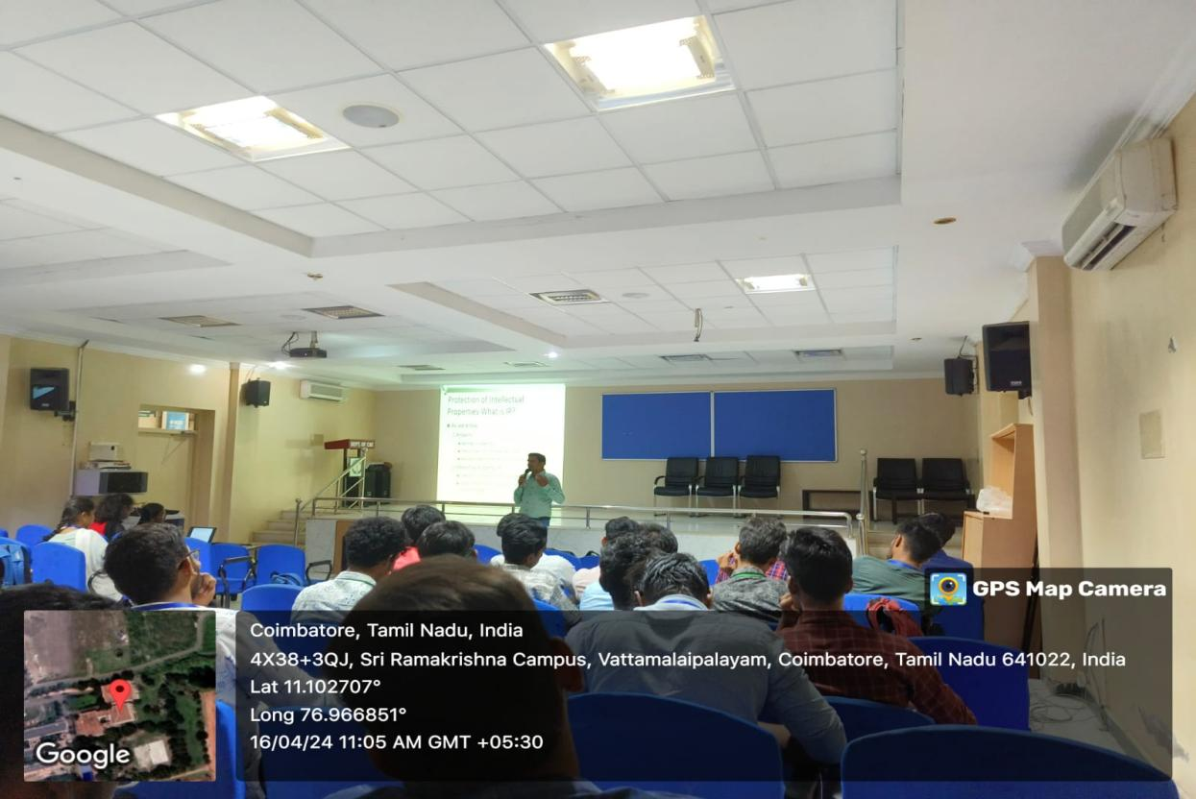

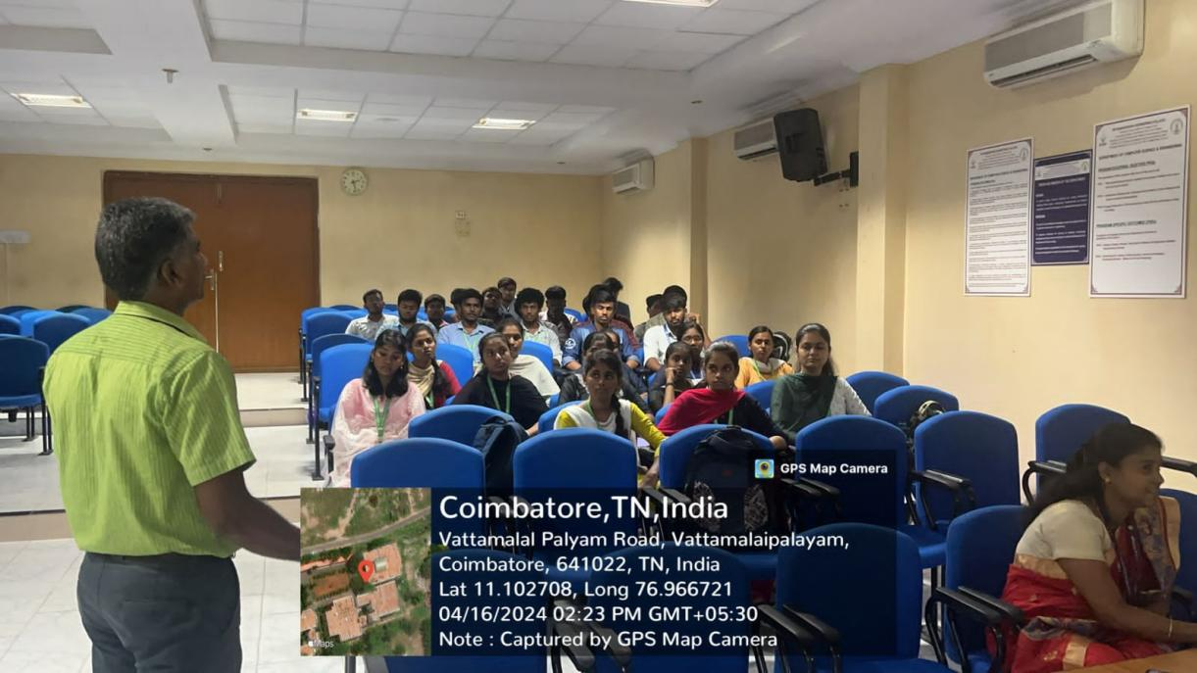

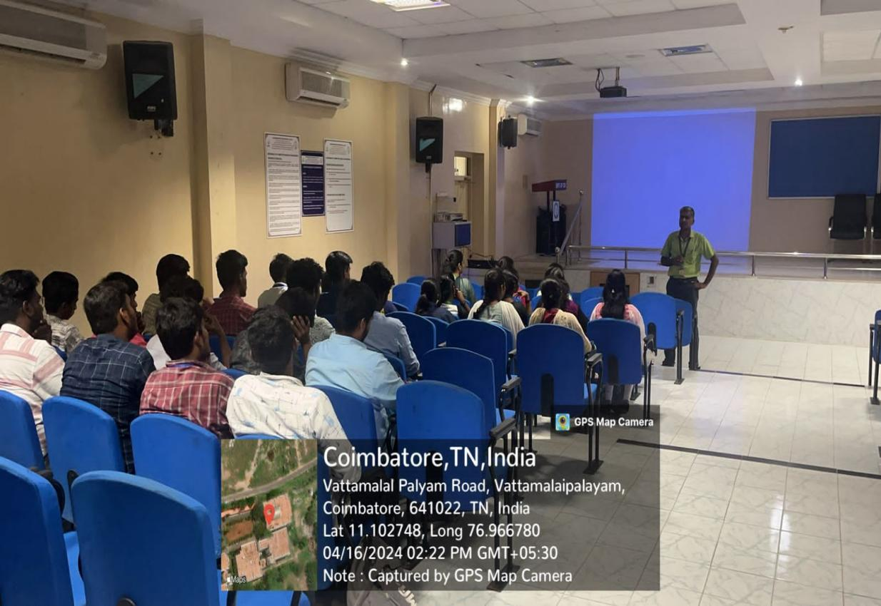

**POSTER DESIGN OF THE EVENT-** 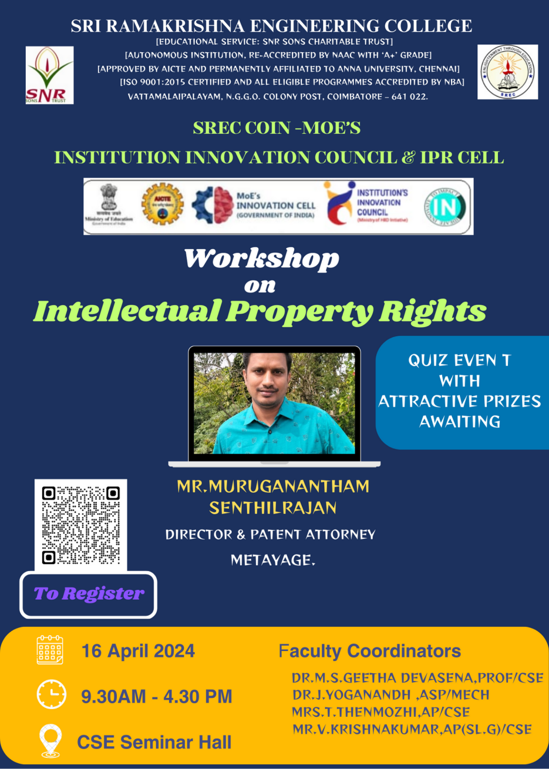

**RESOURCE PERSON PROFILE**

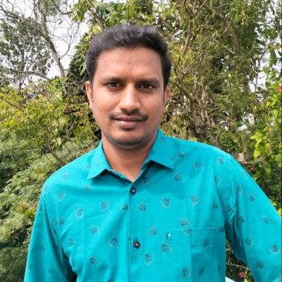

Muruganantham is an Indian Patent Agent with 12 years of experience in India and US patent prosecution. President at Metayage. He heads operations at Metayage and heads the firm’s patent practice. He oversees, direct, and organize the work of the operation team. He is experienced in preparing patent applications, and response to office actions/examination reports in a variety of technology domains, including biotechnology, pharmaceutical, electrical, electronics, mechanical, software Biomedical, Chemistry.

He is experienced in patent searching and analysis in technologies related to Electrical, Electronics, Software, Biotech, and Pharma. His areas of core expertise also include IP Strategy and Consulting and patent due diligence.

He has been participating in IPR related programs conducted by MSME and BCIL. He has been speaker at IPR workshops conducted at academic institutions like Karpagam University, PSG Institute of Technology, Kumaraguru College of technology, Coimbatore Institute of Technology, Vellore Institute of Technology and Kongu Engineering college.

His intellectual property experience includes preparation of patent application in India, Europe and US standards, validity analysis, infringement analysis, and patentability analysis for domestic and international clients in biotechnology, biochemical and pharmaceuticals arts. He has completed a course on IP valuation.

Specialties:

• Drafting and filing Provisional/Non-provisional Patent Application according to Indian, US and European Standards

• Patent prosecution in India, US and EP

• Drafting response to First Examination Reports / Office actions / European Examination report

• Filing PCT applications with WIPO

• Filing conventional and national phase application in India

• Handling foreign filings in Europe, Canada, Germany, France, UK, Australia, Singapore, China, Japan, South Korea and South Africa

• Validity and Invalidity search

• Freedom to practice or clearance search • Infringement Analysis

**MoE IIC-Coordinators MoE IIC-Convenor President-IIC**

Mrs.G.Rathi Dr.N.R.Alamelu